**Australian Islamic College 2018**

**ATAR Chemistry Units 3 and 4**

**Task 6 (Weighting: 3%)**

**Volumetric Analysis Test**

Test Time: 45 minutes

Please do not turn this page until instructed to do so.

|  |  |
| --- | --- |
| **First Name** | **Surname** |
|  |  |

|  |
| --- |
| **Teacher** |
|  |

|  |  |
| --- | --- |
| **Mark / 48** | **Percentage** |
|  |  |

Equipment allowed: Pens, pencils, erasers, whiteout, rulers and non-programmable calculators permitted by the Schools Curriculum and Standards Authority.

**Special conditions**: 2 marks will be deducted for each of these: Failing to write your full name on this test paper; failing to use the multiple choice answer sheet correctly.

Multiple choice questions must be answered on the multiple choice answer sheet provided. Answers placed elsewhere will not be marked.

Teacher help: Your teacher can only help you during your test in one situation.

If you believe there is a mistake in a question show your teacher and your teacher will tell you whether or not there is a mistake in the question and if appropriate, how to fix that mistake.

Short answer questions must be answered in this booklet, in the spaces provided.

Total marks: 48

**PART 1: Multiple Choice 12 marks**

Write your answers on the multiple choice answer sheet at the back of this paper.

1. Which of the following contains a **bolded atom** in a different oxidation state to the rest?

(a) K**As**O4

(b) H**N**O3

(c) H4**Bi**2O7

(d) H**P**O42-

2. Concentrated sulfuric acid (H2SO4) is able to act as an oxidising agent. Which one of the following equations illustrates this ability?

(a) 2NaOH + H2SO4 → Na2SO4 + 2H2O

(b) Zn + 2H2SO4 → ZnSO4 + 2H2O + SO2

(c) NaCl + H2SO4 → NaHSO4 + HCl

(d) 2NH3 + H2SO4 → (NH4)2SO4

3. Which one of the following is/are redox reactions?

1. Zn(s) + 2H+(aq) + 2NO3-(aq) → Zn(NO3)2(aq) + 2NO2(g) + 2H2O(l)
2. Ba2+(aq) + SO42-(aq) → BaSO4(s)

iii. CaCO3(s) → CaO(s) + CO2(g)

iv. 2Na(s) + 2H2O(l) → 2NaOH(aq) + H2(g)

v. Fe(s) + Cu2+(aq) → Cu(s) + Fe2+(aq)

(a) i and ii only

(b) ii and v only

(c) ii, iii and iv

(d) i, iv and v

4. Which of the following would oxidise bromide ion (Br -)but not chloride ions (Cl -) from a 1.0 mol L-1 solution mixture containing both NaBr(aq) and NaCl (aq)?

(a) A 1.0 molL-1 solution of acidified K2Cr2O7

(b) A 1.0 molL-1 solution of acidified H2O2

(c) A 1.0 molL-1 solution of Mn(NO3)2

(d) A 1.0 molL-1 solution of KF

5. Which of the following reactions is **unlikely** to occur under standard conditions of 25 oC and 1.0 mol L-1 solutions?

(a) H2S(aq) + Cl2(aq) → S(s) + 2Cl-(aq) + 2H+(aq)

(b) H2O2(aq) + Cl2(aq) → O2(g) + 2H+(aq) + 2Cl-(aq)

(c) 2Cl-(aq) + Cu2+(aq) → Cu(s) + Cl2(g)

(d) 2Fe3+(aq) + Fe(s) → 3Fe2+(aq)

6. One classical example of an electrochemical cell is the Daniel cell

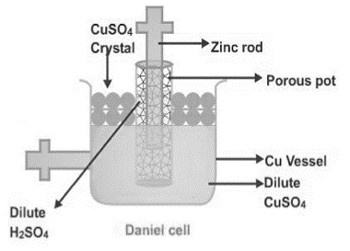

The positive electrode in the Daniel cell above is the

(a) zinc rod

(b) copper vessel

(c) porous pot

(d) CuSO4 crystal

7. The half equations and standard reduction potentials for the ions Cu+(aq) and Cu2+(aq) are as follows:

Cu+(aq) + e- → Cu(s) Eo = + 0.52 V

Cu2+(aq) + e- → Cu+(aq) Eo = + 0.15 V

The standard potential, in Volts, for the disproportionation reaction: **2Cu+(aq) → Cu2+(aq) + Cu(s)** is

(a) - 0.67 V

(b) - 0.37 V

(c) + 0.37 V

(d) + 0.67 V

8. In an experiment performed at standard conditions, a student made the following observatory notes:

i. clean metal A did not react with 1.0 mol/L solution containing B2+ ions

1. clean metal B dissolved in 1.0 mol/L solution containing C2+ ions and crystals of C appeared
2. clean metal C did not react with 1.0 mol/L solution containing A2+ ions

According to the notes, the order of strength as an oxidising agent is

(a) C2+ ions > A2+ ions > B2+ ions

(b) C2+ ions > B2+ ions > A2+ ions

(c) A2+ ions > B2+ ions > C2+ ions

(d) B2+ ions > A2+ ions > C2+ ions

9. An electrochemical cell made from the following reaction has a voltage reading of 1.03 V

Cl2 + 2V3+ + 2H2O → 2VO2+ + 4H+ + 2Cl-

What is the standard reduction potential for the reaction where VO2+ is converted to V3+?

(a) - 3.05 V

(b) - 0.33V

(c) + 0.33 V

(d) + 3.05V

10. Consider a zinc/copper electrochemical cell containing copperelectrode in 1.0 mol L-1 copper(II) sulfate solution and zinc metal in 1.0 mol L-1 Zn(NO3)2 solution.

Which of the following saturated solutions at 25 oC and atmospheric pressure can be used as a salt bridge?

(i) NaNO3 (ii) KBr (iii) Na2CO3

(a) i only

(b) i and ii only

(c) i and iii only

(d) all three solutions are suitable

11. A group of students is designing an electrochemical cell consisting of two half cells joined by a salt bridge.

Each of the half-cells consists of a metal rod placed in a 1.0 mol L−1 solution of its nitrate. Which of the

following pairs of half-cells will produce the highest voltage (EMF) under standard conditions?

(a) Aluminium in aluminium nitrate solution and iron in iron(II) nitrate solution.

(b) Copper in copper(II) nitrate solution and zinc in zinc nitrate solution.

(c) Lead in lead(II) nitrate solution and manganese in manganese(II) nitrate solution.

(d) Silver in silver nitrate solution and magnesium in magnesium nitrate solution.

12. Four metals **Pb**, *x,* *y* and *z*, were connected in pairs and the voltage was recorded.



The results obtained are set out in the table below. What is the order of increasing ease of oxidation of the metals?

|  |  |  |
| --- | --- | --- |
| ***Negative terminal*** | ***Positive terminal*** | ***Voltage (V)*** |
| **Pb** | *x* | 0.35 |
| *y* | **Pb** | 1.10 |
| *z* | **Pb** | 2.60 |

(a) *z*, *y*, Pb, *x*

(b) Pb, *x*, *y*, *z*

(c) *x*, *y*, Pb, *z*

(d) *x*, Pb, *y*, *z*

**PART 2 : SHORT ANSWER 36 marks**

Answer each of the following questions in the space provided.

**Question 1 4 marks**

Write balanced equations for the reactions that occur in the following experiments. Use **ionic** equations where appropriate. In each case describe observations such as colour changes, precipitate formation (give the colour), or gas evolution (give colour or describe as colourless) resulting from the chemical reactions. **Include** state subscripts.

|  |
| --- |
| (a) A strip of chromium metal is placed in a 1.0 mol L-1 solution of cobalt (II) nitrate solution. |
| Equation: |
| Observation: |

[2 marks]

|  |
| --- |
| (b) A small quantity of bromine water (Br2(aq)) is added to 10.0 mL of 1.0 mol L-1 sodium iodide solution. |
| Equation: |
| Observation: |

[2 marks]

**Question 2 3 marks**

According to Wikipedia, hypoiodous acid (**HIO**) is highly likely to be the active ingredient responsible for

disinfection by iodine solutions used in the medical profession. Examples of such solutions include betadine or

povidone.

Hypoiodous acid is quite unstable and it disproportionates to form iodic acid (HIO3) and iodine solutions.

Write half equations to show the oxidation and reduction of hypoiodous acid and the overall redox equation for the disproportionation of hypoiodous acid.

|  |
| --- |
| Oxidation half equation: |
| Reduction half equation: |
| Overall redox equation: |

**Question 3 14 marks**

The following diagram represents an electrochemical cell based on chromium and nickel electrodes in 1.0 mol L-1 electrolyte solutions. A porous barrier separates the two half cells but allows ions to migrate between them. The cell operates under standard conditions.

Cr(NO3)3 solution

NiSO4

solution

**Ni**

# Cr

(a) Write the anode, cathode and overall redox equation for the cell above. [3 marks]

Anode: _______________________________________________________________________________

Cathode: _____________________________________________________________________________

Overall: ______________________________________________________________________________

(b) On the diagram, label the electrode that is the anode. [1 mark]

(c) Draw an arrow in the box provided to show the direction of the electron flow in the wire. [1 mark]

(d) What is the maximum theoretical EMF (voltage) that can be generated? (Assume 1.0 mol L−1 concentrations and standard conditions) [1 mark]

__________________________________________________________________________

(e) Which anion (negative ions) will migrate through the porous barrier? [1 mark]

__________________________________________________________________________

(f) State two (2) changes that will be observed. [2 marks]

1. ____________________________________________________________________
2. ____________________________________________________________________

(g) What will be observed if the porous barrier is removed and the solutions become mixed? [2 marks]

______________________________________________________________________________________

______________________________________________________________________________________

______________________________________________________________________________________

______________________________________________________________________________________

______________________________________________________________________________________

______________________________________________________________________________________

(h) The standard reduction potential for nickel metal is (- 0.24 V). Explain the role of the hydrogen half-cell in determining this value. Comment on the significance of the negative value. You may use diagrams to aid your explanation. [3 marks]

______________________________________________________________________________________

______________________________________________________________________________________

______________________________________________________________________________________

______________________________________________________________________________________

______________________________________________________________________________________

______________________________________________________________________________________

______________________________________________________________________________________

**Question 4 3 marks**

Rusting occurs when iron metal is exposed to air. The **unbalanced chemical** equation for the rusting process is below:

**Fe(s) + O2(g) + H2O(l) → Fe2+(aq) + OH–(aq)**

(a) Balance the chemical equation above. [2 marks]

(b) In many situations, the first visible sign of iron corrosion is the formation of a light green powder on the affected metal. Write a suitable **ionic** chemical equation to explain this observation.

____________________________________________________________________________ [1 mark]

**Question 5** **5 marks**

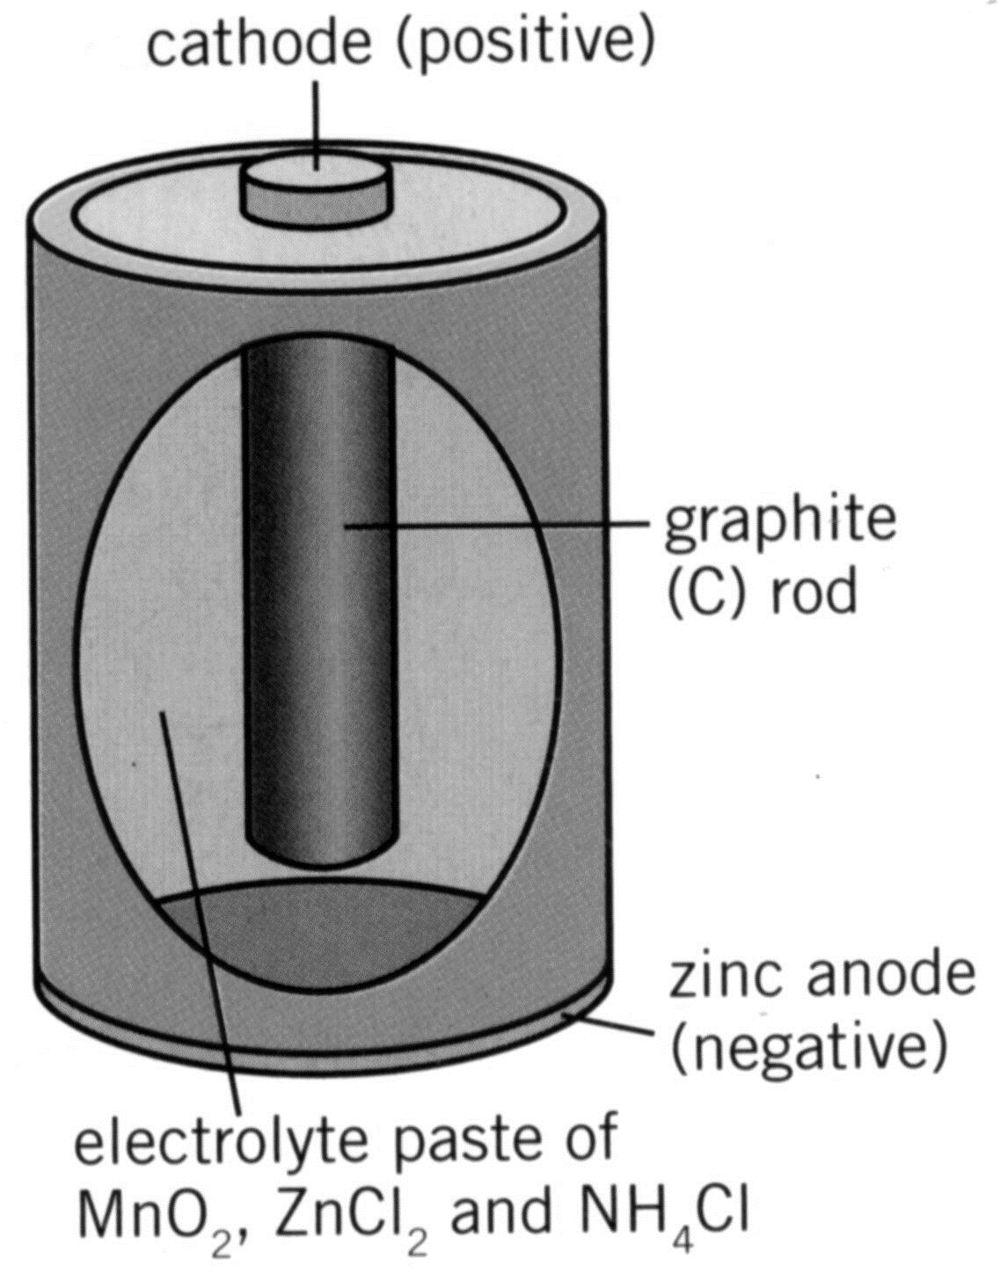Below is a diagram of the common dry cell:

Given the cathode reaction is:

2MnO2(s) + 2H+(aq) + 2e- **→** Mn2O3(s) + H2O(l)

(a) Determine the oxidation state of the Mn before and after the reaction:

Before: _________ After: __________ [2 marks]

(b) State the oxidant in the cell: _______________________ [1 mark]

(c) Given that the anode reaction is the oxidation of zinc, write the equation for the overall reaction of the cell:

___________________________________________________________________________ [2 marks]

**Question 6 7 marks**

The lead acid battery, or accumulator, is commonly used in motor vehicles and consists of six cells connected in series.

When **discharging**, the electrode reactions are:

ANODE: Pb(s) + SO42-(aq) **→** PbSO4(s) + 2e-

CATHODE: PbO2(s) + 4H+(aq) + SO42-(aq) + 2e- **→** PbSO4(s) + 2H2O(l)

| Part | Question | Answer |
| --- | --- | --- |
| (a) | During the recharging process, what is the  i. reducing agent?  ii. oxidising agent? | i.  ii.  [2 marks] |
| (b) | How would the concentration of the electrolyte change during the **recharging** process? | Circle one of the choices below  INCREASE DECREASE UNCHANGED  [1 mark] |
| (c) | How would the pH inside the battery change during:  i. recharging?  ii. discharging? | Circle one of the choices in parts (i) and (ii)  i.INCREASE DECREASE UNCHANGED  [1 mark]  ii.INCREASE DECREASE UNCHANGED  [1 mark] |
| (d) | State one advantage and one disadvantage of this battery. Explanation is not required. | Advantage:  [1 mark]  Disadvantage:  [1 mark] |

**MULTIPLE CHOICE ANSWER SHEET**

